**Personnel responsible:**

All Production Operators and Material Handlers

**Safety:**

Safety shoes and safety glasses are required when working in the plant.

Safety Belt is required when operating a Fork Lift

**Summary:**

All finished crystal product is staged in Upper or Lower warehouses located adjacent to the packaging and press area. Finished crystal product is staged in the warehouses as full loads for ease of tracking and loading. The loading dock is located adjacent to the Lower Warehouse. Giles can only load one truck at a time. Numerous Drivers can be staged in the parking area on Miller Street to simplify loading and street congestion. All arrangements, including paper work, for shipping and transfers are handled by the Lead Customer Service Representative or Accounting Associate.

**Procedure;**

1. When a driver shows up for a load he is to go to the staging area located on Miller Street and call the plant. First available employee should answer the phone, and ask the driver for his pick up number. Operator should reference the pick up number to the loading board. If a matching number is found proceed to item number 2 of this procedure. If there is no matching number, first ask the driver which street address he is picking up at, he could have called the wrong facility. If he called the correct facility, the driver must call his dispatcher and get a correct number.
2. Find the corresponding Bill Of Lading (BOL) that matches the pick up number out of the BOL box and use the time clock to clock the driver in on the top sheet (pick slip) recording what time the driver arrived at the staging area.
3. If there is no truck in the dock, tell the driver where to back in. If there is a truck already in the loading dock being loaded, write the drivers phone number on the pick slip so you can contact him when the dock is available. Loading is first come first served so we load drivers in the order in which they are clocked in.
4. Once the driver is in the dock take the BOL to the driver, show the driver the amount and weight of the order. Have the driver initial beside pick up number stating it is the correct number. Using the "Truck Loading Time" stamp, stamp the top sheet (pick slip) of the BOL and then use the time clock to clock the driver in beside "Truck Arrived".
5. Locate the bin number beside the order on the shipping board, if no bin number is indicated, find a load completely matching order description in the warehouse. The loader should carefully read the order information both on the Pick Slip and the BOL in order to insure the correct amount and product is loaded. It is the loader's responsibility to make sure the Special Customer Requirement (SCR) code is followed. The SCR number is located on the Pick slip and the BOL. The SCR information is on the Documentation system.
6. As the driver is backing into the dock, it is good practice to stage the load. Begin taking the pallets from their bin and place them in an orderly manner near the loading dock for easy and quick loading.
7. Trucks are to be loaded according to the loading chart on page 7 of this procedure. If a driver would like to be loaded a different way it can be done but it is the driver's responsibility from that point forward. The driver is to be informed if it is off weight on the axles we do not take responsibility and will not unload once it has left Giles premises. Once you inform the driver of this write a note on the pick slip stating that the driver changed the configuration and have driver sign it.
8. If the truck is not present during loading, jack stands much be placed under the trailer while loading.
9. While loading the truck, fill out the second page of the pick slip with checking each pallet for SCR Code compliance, hardness, print quality and leaking or torn bags. DO NOT LOAD if items are unacceptable.
10. Fill out a corresponding Certificate of Analyses (C of A) to be sent with the load.
11. After the truck is loaded, on the Pick Slip the loader signs and dates pallet check and clocks the driver out using the time clock beside the "Loading Completed" section of the "Truck Loading Time" stamp. Both the Loader and the Driver must initial loading times stating when the truck arrived and when it was finished loading.
12. On the BOL the loader writes down Trailer number in vehicle number slot. The Lot number and the Seal number are to be written in the center section. The loader should then sign, date and put the time loading and paper work was completed in the designated area at the bottom. Have the driver sign and date in designated area. Keep the top copy for the office. Give the driver the second copy. Fold the third copy of the BOL with a Certificate of Analysis and any other customer required paper work. Put third copy and all other paper work in a shipping pouch, peal off the paper revealing the self adhesive back and attach to the last pallet on the load.
13. Have the driver pull up 10 to15 feet in the dock and close his doors then physically put the seal on the truck after the driver closes the trailer doors.
14. Sign off the load on loading board and place finished paper work in the BOL box ready for office pick up.

**CRYSTAL LOADING CHECK LIST**

1. Get pick up number from the driver
   1. If no matching number, driver must call their dispatcher
   2. GILES **DOES NOT** LOAD WITHOUT A PICK UP NUMBER
2. Match number from the Driver with the load on the Load Board and then get the correct Bill of Lading from BOL box.
   1. Driver must initial Pick up number before being clocked in.
3. Once numbers match Clock Driver in on the top page of the BOL
   1. If trucks are ahead of driver, write phone number on Pick Slip beside the 1st clock in.
4. When dock is open, Instruct driver to back in and use supplied stamp and digital time clock to clock driver in to be loaded. .
5. Check BOL and or pick slip for Special Customer Requirements ( SCR Code )
   1. Find correlating SCR code on the Documentation System.
6. Check BOL for product ID and product amount needed for the load
7. Check **EACH AND EVERY** pallet for;
   1. SCR compliance, Wrap not torn, Pallet in good condition. No torn or leaking bags, Print on pallet clear ( both from printer and operator ) and Bags feel soft ( not crunchy or hard )
8. Inspect empty trailer for dirt, trash and structural integrity.
   1. Standing at the entrance of the trailer, take one photo of empty trailer
9. Use Trailer Stands if Tractor will not be under the Trailer during loading
10. Load Truck according to Giles policy - loading chart
    1. Contact Plant Manager, Production Manager or Customer Service Representative before adjusting any load amount.
    2. With a single line mark though any corrections on all paper work
    3. Legible write in the new amount and weight to be loaded, and initial beside each.
    4. On the top sheet of pick slip write down the reason for shorting the load.
11. Fill out the second page of the Pick Slip with proper information ( while loading )
12. Loader must sign off on “checking load conditions box” on the Pick Slip
13. Standing at the entrance of the trailer, take one photo of loaded trailer
14. Get a matching Certificate of Analysis for each lot number in the load.
15. Put Trailer number, Seal number and Lot Number on BOL
16. Clock driver out on the Pick Slip - Have driver initial times.
17. Take one picture of completed Pick Slip to go with the 2 pictures taken of the trailer
18. Loader and Truck Driver Signs BOL with Date and 24 hour time.
19. Copies of the Completed Bill of Lading
    1. Giles gets top copy and Driver gets second copy.
    2. Fold third copy and place in a shipping pouch with all other customer related papers and stick to shrink wrap on the last pallet of the load in the truck.
20. Put seal on Truck – Loader must be present during seal application
21. Sign load off on shipping board and place paper work in "shipped box"

PICK SLIP

The Pick slip is the top sheet of a Bill of Lading or BOL. The Pick Slip is generated by the Customer Service Department when a Customer places and order. This is a quick reference of the BOL and customer order, this is information telling the loader what material and what amount the customer has ordered.

1. Get Pick up number from driver, compare number to Loading Board. Then find the corresponding BOL and Pick sheet.
2. Have Driver initial beside the Pick Up number on the pick slip.
3. Clock Driver in when they arrive and before you start loading and when finished
4. Check Product code and Amount needed.
5. Check off what location you are shipping the product from.
6. Check the condition of pallets, bags, print, hardness and SCR number before loading product. Sign off stating you have checked everything and it is acceptable.
7. SCR code is the Special Customer Requirements for the customer.

Pick Up Number *(Driver Initials here)*

Shipping Location

Pick Slip

Customer - Customer name BOL NUMBER : ~~~~~~~~~~~~~~~

CUSTOMER PO NUMBER ~~~~~~~

3RD PARTY PO NUMBER ~~~~~~~

Ship To: Ship From

Customer Name and 🗌 102 Commerce Street

Ship to address 🗌 396 Smathers Street

🗌 202 Lea Plant Road

State 🗌 _________________

**Condition of pallets, bags/boxes, print hardness or salt and the SCR has been checked on this load**

NAME ____________________________ DATE ____________ TIME ____________

T-50 882

Tech Grade Epsom Salt in 50lb bags

SCR # 23

Pick Slip

Customer - Customer name BOL NUMBER : ~~~~~~~~~~~~~~~

CUSTOMER PO NUMBER ~~~~~~~

3RD PARTY PO NUMBER ~~~~~~~

Ship To: Ship From

Customer Name and 🗌 102 Commerce Street

Ship to address 🗌 396 Smathers Street

🗌 202 Lea Plant Road

State 🗌 _________________

**Condition of pallets, bags/boxes, print hardness or salt and the SCR has been checked on this load**

NAME ____________________________ DATE ____________ TIME ____________

T-50 882

Tech Grade Epsom Salt in 50lb bags

SCR # 23

Number of bags

needed

Product Code and Description

Sign off stating you have checked material and it is acceptable

SCR Code - Check Documentation System for instructions

Phone # JAN 12 AM 9:24

Clock driver in after matching up pick up number and record phone number if necessary

Truck Loading Time

Truck Arrived __________________

Loading Completed _____________

Driver ________ Loader ________

Stamp paper and Clock driver in before backing into dock

PICK SLIP PAGE 2

The Second page of the Pick slip is for documenting the pallet information as it is being loaded on a truck. This is also key information for the Customer Service Department as well as the Quality Control Department and Inventory control.

1. As you load the product on a truck, check each pallet for SCR requirements, Print clarity and Salt condition. Check each box for each pallet
2. A line may be drawn to indicate that all are the same. Line may be drawn for Item, Lot Number, OPR and Production date only.
3. If two or more different lot number, operator, or production dates are loaded, each lot number, operator number or date must be entered.
4. When drawing lines to indicate all the same, write in the first and last of numbers and dates and draw line connecting them.



**PICK SLIP - PAGE 2**

|  |  |  |  |  |  |  |  |
| --- | --- | --- | --- | --- | --- | --- | --- |
|  | ☑  SCR | ☑  PRINT | ☑  SALT | ITEM | LOT  NUMBER | OPR | PRODUCTION DATE |
| 1 |  |  |  |  |  |  |  |
| 2 |  |  |  |  |  |  |  |
| 3 |  |  |  |  |  |  |  |
| 4 |  |  |  |  |  |  |  |
| 5 |  |  |  |  |  |  |  |
| 6 |  |  |  |  |  |  |  |
| 7 |  |  |  |  |  |  |  |
| 8 |  |  |  |  |  |  |  |
| 9 |  |  |  |  |  |  |  |
| 10 |  |  |  |  |  |  |  |
| 11 |  |  |  |  |  |  |  |
| 12 |  |  |  |  |  |  |  |
| 13 |  |  |  |  |  |  |  |
| 14 |  |  |  |  |  |  |  |
| 15 |  |  |  |  |  |  |  |
| 16 |  |  |  |  |  |  |  |
| 17 |  |  |  |  |  |  |  |
| 18 |  |  |  |  |  |  |  |
| 19 |  |  |  |  |  |  |  |
| 20 |  |  |  |  |  |  |  |
| 21 |  |  |  |  |  |  |  |
| 22 |  |  |  |  |  |  |  |
| 23 |  |  |  |  |  |  |  |
| 24 |  |  |  |  |  |  |  |

OPR Initials ___________ Date : ____ / ____ / _____



**PICK SLIP - PAGE 2**

|  |  |  |  |  |  |  |  |
| --- | --- | --- | --- | --- | --- | --- | --- |
|  | ☑  SCR | ☑  PRINT | ☑  SALT | ITEM | LOT  NUMBER | OPR | PRODUCTION DATE |
| 1 | 🗸 | 🗸 | 🗸 | *T-50* | *0606* | *2* | *04/05/06* |
| 2 | 🗸 | 🗸 | 🗸 |  |  |  |  |
| 3 | 🗸 | 🗸 | 🗸 |  |  |  |  |
| 4 | 🗸 | 🗸 | 🗸 |  |  |  |  |
| 5 | 🗸 | 🗸 | 🗸 | *T-50* | *0606* | *2* | *04/05/06* |
| 6 | 🗸 | 🗸 | 🗸 | *T-50* | *0606* | *1* | *04/06/06* |
| 7 | 🗸 | 🗸 | 🗸 |  |  |  |  |
| 8 | 🗸 | 🗸 | 🗸 |  |  |  |  |
| 9 | 🗸 | 🗸 | 🗸 |  |  |  |  |
| 10 | 🗸 | 🗸 | 🗸 |  |  |  |  |
| 11 | 🗸 | 🗸 | 🗸 |  |  |  |  |
| 12 | 🗸 | 🗸 | 🗸 |  |  |  |  |
| 13 | 🗸 | 🗸 | 🗸 |  |  |  |  |
| 14 | 🗸 | 🗸 | 🗸 |  |  |  |  |
| 15 | 🗸 | 🗸 | 🗸 |  |  |  |  |
| 16 | 🗸 | 🗸 | 🗸 |  |  |  |  |
| 17 | 🗸 | 🗸 | 🗸 |  |  |  |  |
| 18 | 🗸 | 🗸 | 🗸 |  |  |  |  |
| 19 | 🗸 | 🗸 | 🗸 |  |  |  |  |
| 20 | 🗸 | 🗸 | 🗸 |  |  |  |  |
| 21 | 🗸 | 🗸 | 🗸 |  |  |  |  |
| 22 | 🗸 | 🗸 | 🗸 | *T-50* | *0606* | *1* | *04/06/06* |
| 23 |  |  |  |  |  |  |  |
| 24 |  |  |  |  |  |  |  |

OPR Initials ___________ Date : ____ / ____ / _____

Check SCR requirements, Print clarity, and Salt condition on each pallet

Two different production dates and Operators

STRAIGHT BILL OF LADING

The Bill of Lading is generated by the Customer Service Department when a Customer places and order. Just like the Pick sheet, this is key information telling the loader what material and what amount the customer has ordered as well as ship to location. There are three copies of the bill of lading, one for the office, one for the driver and the last one to be used as a packing slip and placed on the last pallet.

1. When you have completed load, Sign BOL with Date and 24:00 hour time.
2. Disperse the 3 copies of completed BOL
   1. Keep top copy
   2. Driver gets 2nd Copy
   3. Take last copy, fold and place inside a packing pouch and stick to last pallet.
3. Before Loading, check BOL for amount and product description.
4. Double check Pick Up number and Shipping Location.
5. Loader fills in
   1. Vehicle Number
   2. Lot Number
   3. Seal Number

STRAIGHT BILL OF LADING

ORIGNAL - NOT NEGOTIABLE

BOL # ________________

US dot Hazmet Reg # ________________________

DATE ________________

_________________Name of Company____________________

( name of Carrier )

|  |  |  |  |  |  |  |  |
| --- | --- | --- | --- | --- | --- | --- | --- |
| TO:  Name of Customer  Address  City, State | | | FROM:  Giles Chemical Corporation  102 Commerce Street  Waynesville, NC 28786 | | | | |
| Vehicle Number  6812 | | Ship To PO  1005698 | | | | Customer PO  144325695 | |
| No. Shipping  Units | HM | | Kind of Packaging, Description of Article | | | | Weight  lbs |
| 882 |  | | Tech Grade Epsom Salt in 50 lb. Bags | | | | 45,000 |
|  | | | | | FREIGHT CHARGES | | |
| ~~~~~~~~~~~~~~~~~~~~~~~~~~~~~~~~~~~~~~~~~~~~~~~~~~~~~~~~~~~~ | | | | | | | |
| Shipper  Giles Chemical Corporation  Per Doug Myer  Date 04/06/06 Time 16:25 | | | | Carrier  Per Rick Flair  Date 04/06/06 | | | |

STRAIGHT BILL OF LADING

ORIGNAL - NOT NEGOTIABLE

BOL # ________________

US dot Hazmet Reg # ________________________

DATE ________________

_____________________________________

( name of Carrier )

|  |  |  |  |  |  |  |  |
| --- | --- | --- | --- | --- | --- | --- | --- |
| TO:  Name of Customer  Address  City, State | | | FROM:  Giles Chemical Corporation  102 Commerce Street  Waynesville, NC 28786 | | | | |
| Vehicle Number  *6812* | | Ship To PO  1005698 | | | | Customer PO  144325695 | |
| No. Shipping  Units | HM | | Kind of Packaging, Description of Article | | | | Weight  lbs |
| 882 |  | | Tech Grade Epsom Salt in 50 lb. Bags  *Lot # 0606* | | | | 45,000 |
| *11634289* | | | | | FREIGHT CHARGES | | |
| ~~~~~~~~~~~~~~~~~~~~~~~~~~~~~~~~~~~~~~~~~~~~~~~~~~~~~~~~~~~~ | | | | | | | |
| Shipper  Giles Chemical Corporation  Per  Date Time | | | | Carrier  Per  Date | | | |

**Trailer Number**

**Sign, Date and Time of completing load**

**in 24:00 time**

**Lot # and Seal Number**

CHANGING A LOAD

1. If for any reason, something must be changed on a load, you must first call the Plant Manager or designated personnel for approval.
2. With a single line mark through the original amount on the 1st page of the pick slip. Write in the corrected amount. Legible explain the reason for changing the load.
3. With a single line mark through the original amount and weight on all three copies of the BOL. Write in the corrected amounts and initial.

STRAIGHT BILL OF LADING

ORIGNAL - NOT NEGOTIABLE

BOL # ________________

US dot Hazmet Reg # ________________________

DATE ________________

_________________Name of Company____________________

( name of Carrier )

|  |  |  |  |  |  |  |  |
| --- | --- | --- | --- | --- | --- | --- | --- |
| TO:  Name of Customer  Address  City, State | | | FROM:  Giles Chemical Corporation  102 Commerce Street  Waynesville, NC 28786 | | | | |
| Vehicle Number  6812 | | Ship To PO  1005698 | | | | Customer PO  144325695 | |
| No. Shipping  Units | HM | | Kind of Packaging, Description of Article | | | | Weight  lbs |
| 882  833 |  | | Tech Grade Epsom Salt in 50 lb. Bags | | | | 45,000  42,500  DM |
|  | | | | | FREIGHT CHARGES | | |
| ~~~~~~~~~~~~~~~~~~~~~~~~~~~~~~~~~~~~~~~~~~~~~~~~~~~~~~~~~~~~ | | | | | | | |
| Shipper  Giles Chemical Corporation  Per Doug Myer  Date 04/06/06 Time 16:25 | | | | Carrier  Per Zac Guy  Date 04/06/06 | | | |

Pick Slip

Customer - Customer name BOL NUMBER : ~~~~~~~~~~~~~~~

CUSTOMER PO NUMBER ~~~~~~~

3RD PARTY PO NUMBER ~~~~~~~

Ship To: Ship From

Customer Name and 🗌 102 Commerce Street

Ship to address 🗌 396 Smathers Street

🗌 202 Lea Plant Road

State 🗌 _________________

**Condition of pallets, bags/boxes, print hardness or salt and the SCR has been checked on this load**

NAME ____________________________ DATE ____________ TIME ____________

T-50 882

Tech Grade Epsom Salt in 50lb bags 833 - DM

**Trailer Number**

Driver refused to take full load - to heavy!!

DM

**Single strike though and initial with correction.**

**Single strike though and initial with correction and explanation.**

***You must have an explanation on pick slip***

WAREHOUSE CAMERA and LOADING PICTURES

Examples of the 3 pictures that are to be taken of every load shipped

(Repack *shipments may be excluded*)

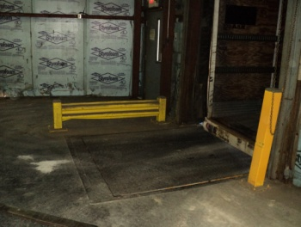

Stand here when taking pictures of trailer

|  |  |
| --- | --- |
| empty truck  #1 – before it is loaded  loaded truck  #2 – After it is loaded | BOL IIII  #3 – completed BOL  that goes with the load |

Giles Loading Configurations

Anything loaded other than pallet configuration listed below is Drivers responsibility

*(Drivers are to sign pick slip stating they want a different configuration than what is listed below)*

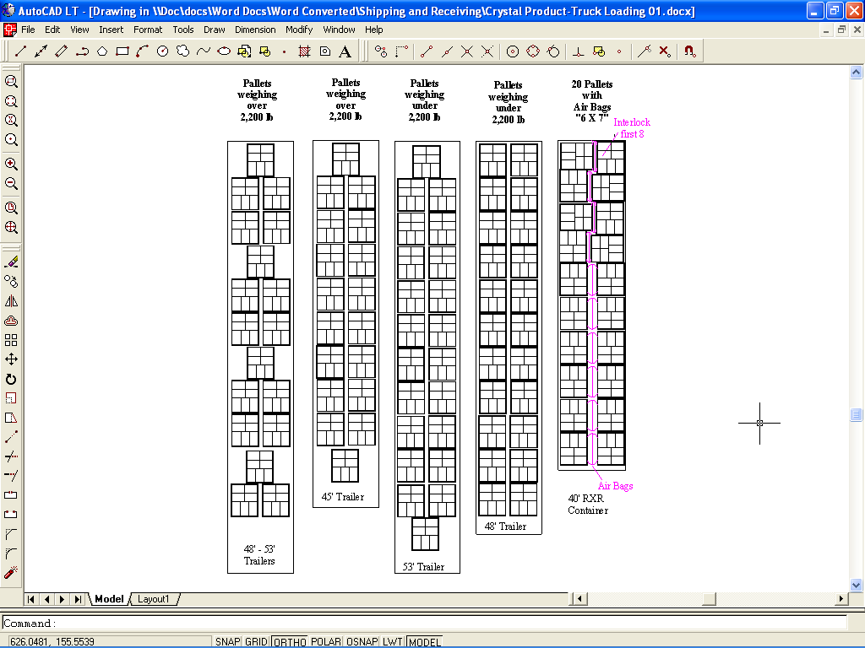

**TRAINING DOCUMENTATION**

|  |  |  |  |  |
| --- | --- | --- | --- | --- |
|  | EMPLOYEE | TITLE | SIGNATURE | DATE |
| 1 |  |  |  |  |
| 2 |  |  |  |  |
| 3 |  |  |  |  |
| 4 |  |  |  |  |
| 5 |  |  |  |  |
| 6 |  |  |  |  |
| 7 |  |  |  |  |
| 8 |  |  |  |  |
| 9 |  |  |  |  |
| 10 |  |  |  |  |
| 11 |  |  |  |  |
| 12 |  |  |  |  |
| 13 |  |  |  |  |
| 14 |  |  |  |  |
| 15 |  |  |  |  |
| 16 |  |  |  |  |
| 17 |  |  |  |  |
| 18 |  |  |  |  |

|  |  |  |  |
| --- | --- | --- | --- |
| Revision  Number | Revision  Date | Revision  Author | Revision Description |
| 00 | 11/14/2005 | JB | New Document |
| 01 | 01/28/2009 | JB | Added Jack Stands |
| 02 | 01/27/11 | JB | Added Camera procedure  clocking in when arrive & when driver is ready to be loaded |
|  |  |  |  |
|  |  |  |  |
|  |  |  |  |
|  |  |  |  |